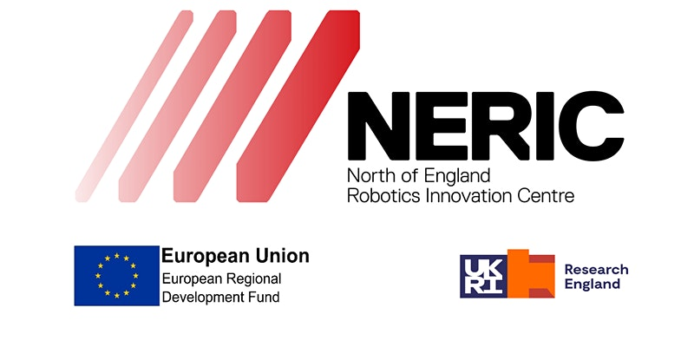

Job Detail
(Overview, Role Detail and Person Specification)

School of Science Engineering & Environment

North of England Robotics Innovation Centre (NERIC)

NERIC Business Development Manager Grade 8 (£42, 149 - £50,296)
Fixed Term Contract -

(Ref: MPFXXXX)

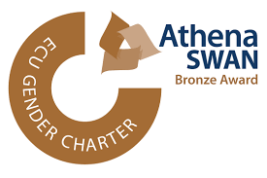

Role Title: Business Development Manager: NERIC

Reports To: Academic Lead
Overview
The University of Salford has a rich history stretching back to 1896 and today is a leading provider of Higher Education based over a Main Campus, one and a half miles from Manchester and several outlying facilities. Currently undergoing a transformational change affecting every area of university life, Salford is positioning itself at the leading edge of higher education institutions in this country

The University of Salford is ambitious and at the heart of a fast-developing community. Our expertise help transform diverse individuals and communities through teaching, research, innovation, and engagement. Salford is at the forefront of this transformation, leading the way in areas such as health, energy, media, and the built environment. Our 20,000 students contribute enormously to the local economy.

As part of its commitment to excellent high-level research, it has developed the North of England Robotics Innovation Centre (NERIC) project under the European Reconstruction and Development Fund (ERDF) and Research England Development fund (RED). This will be an internationally acclaimed research and innovation facility focusing the three sectors of food and drink, healthcare, and intelligent mobility.

The Business Development Manager will be responsible for shaping and delivering the marketing and business engagement strategy of NERIC to ensure the effective delivery of the ERDF / RED and support the future sustainability of the test facility.

Role Detail

Role Purpose
The NERIC Development Manager will drive the engagement with SMEs as part of the CEAIR project. They will provide leadership in the strategy to engage with SMEs and work with the Project Manager to ensure that data is collected and appropriately managed in service of the wider goals of the ERDF/RED projects. This will include designing and managing customer management systems for the NERIC project.

Responsibilities
The Business Development Manager will, in conjunction with the NERIC Manager:

  - Identify potential companies to assist as part of the ERDF/RED projects, including working with external bodies such as the Growth Hub to drive participation
  - Providing leadership in the strategy to engage with companies and work with the Robotics Project Managers to ensure that data is collected and appropriately managed in service of the wider goals of the ERDF/RED projects
  - Designing and managing customer management systems for the Robotics centre project.
  - Develop marketing materials and web presence in conjunction with the wider NERIC team
  - Help drive business development and manage relationships with companies during the life of the project.

  - Ensure market knowledge and intelligence is kept updated and the NERIC is promoted and marketed

  - Develop long term strategic relationships with university partners through a variety of initiatives.

  - Assist in the management process of activity development from conception through to fully developed proposals.

  - Promote equality and diversity for students and staff and sustain an inclusive and supportive study and work environment in accordance with university policy.

  - Perform any other duties appropriate to the grade as may be required by the NERIC Manager

  - Comply with the personal health and safety responsibilities specified in the University Health and Safety policy

  - In addition to the duties and responsibilities listed, the post holder is required to perform other duties assigned by the Line Manager from time to time.

  - To engage with the University’s commitment to deliver value for money services that optimises the use of resources by maintaining a cost-conscious approach when undertaking all duties and aspects of the role.

  - To promote equality and diversity and sustain an inclusive work environment in accordance with university policy

Person Specification

Qualifications

The successful candidate should have: |  | Essential/ Desirable | Tested by* A, I, P, T
1 | Have a First degree (in a relevant subject) or equivalent commercial industrial experience within sales and businesses development role in a HEI environment | E | A
2 | Professional or postgraduate qualifications (in relevant subject) | D | A

Background & Experience

The successful candidate should have: |  | Essential/ Desirable | Tested by* A, I, P, T
3 | Experience of working with regional SMEs on European Funded Projects | E | A/P
4 | Experience of collaborating with industry / academia on previous projects | E | A/I
5 | Experience of undertaking planning and managing events and exhibitions. | E | A/I

Knowledge

The successful candidate should have demonstrable knowledge of: |  | Essential/ Desirable | Tested by* A, I, P, T
6 | Advanced IT skills | D | A/I
7 | Knowledge of ERDF guidelines and regulations in relation to SME assists | E | A/I/P
8 | Knowledge of project management | E | I
9 | Experience of staff management and support | D | I
10 | Proven track record in customer relationship management | E | I
11 | An awareness of the relevant sectors | E | A/I

Skills & Competencies

The successful candidate should demonstrate: |  | Essential/ Desirable | Tested by* A, I, P, T
12 | Highly effective verbal and written communication skills | E | A/I
13 | Ability to meet and work to commercial deadlines | E | A/I
14 | Problem solving skills | E | I
15 | Team working skills | E | I
16 | Commitment to equal opportunities | E | I
17 | Ability to work autonomously, with little supervision, as well as being a co-operative team member | E | I
18 | Demonstration of initiative to identify and develop opportunities | E | A/I

A= Application Form, I = Interview, P = Presentation, T = Test

Candidate guidance

**In order to fully meet the essential criteria candidates must show clear evidence of how they meet the criteria. Simply stating that you have a skill or experience in an area is not sufficient, you must provide a clear example to show how you have met each of the criterion you address.

